CARES

European Outlook on Care

National report

Luca Koltai
Hétfa Research Institute

02.04.2025

CARES – Caregivers Advancing Regulatory Environment and
Skills

Project acronym
CARES

Project no. 2024-1-RO01-KA220-ADU-000251559

Deliverable title
A2.1 Benchmark report – European Outlook on Care

DOCUMENT CONTROL SHEET
AUTHOR(S) | Luca Koltai
REVIEWER(S) | Adrienn Kiss
DISSEMINATION LEVEL | PU
START DATE OF PROJECT | 03/11/2024
DURATION OF THE PROJECT | 24 months
SUBMISSION DATE | 14/04/2025
ORGANISATION NAME OF LEAD CONTRACTOR FOR THIS DELIVERABLE | Asociația Centrul pentru Legislație Nonprofit (CLNR)

VERSIONING AND CONTRIBUTION HISTORY
VERSION | DATE | MODIFICATION REASON | MODIFIED BY
1.0 | 10 April 2025 | Proofreading | Adrienn Kiss
2.0
3.0

Table of contents
List of figures 1
1. Need for better social care 2
2. European Policy framework on ageing and care 11
3. Social care sector in Europe 15
References 18

List of figures
Figure 1 Projected old-age dependency ratio in the European Union in 2100 (%) 4
Figure 2 Healthy life expectancy at age 65 in the European Union and Hungary in 2021 (years) 6
Figure 3 Share of pupils below the starting age of compulsory education at primary level who are enrolled in early childhood education 8

Need for better social care
The issue of demographic challenges is becoming increasingly salient within the European Union. In her 2023 State of the Union address, Ursula von der Leyen underscored the demographic challenges confronting Europe, while Dubravka Šuica, serving as the EU Commissioner for Democracy and Demography, appreciated that this position will no longer exist after 2024.
Demographic issues are garnering increasing attention among European citizens. According to the 2023 Eurobarometer survey, Europe’s ageing population (42%) and the decline in the working age population and labour shortages (40%) were identified as the most pressing demographic challenges by respondents across the Member States. This was followed by migration and integration challenges (34%), depopulation and brain drain (26%), and declining fertility (21%). However, it should be noted that these challenges vary in their perceived urgency from one country to another. Specifically, population ageing was identified as the most pressing challenge in eight Member States (Poland, the Netherlands, Portugal, Spain, Slovenia, Czechia, Cyprus, and Italy), while declining populations in the working age category was highlighted in five Member States (Belgium, Denmark, Romania, Lithuania, and Ireland). Immigration was noted as a concern in six Member States (Germany, Luxembourg, Cyprus, Sweden, Malta, and Austria), depopulation and labour drain in five countries (Hungary, Slovakia, Croatia, Estonia, and Bulgaria), and declining fertility in three Member States (Finland, Latvia, and Estonia).
In 2022, the proportion of the EU population aged 65 and over exceeded 21.1%, representing a substantial increase from the 17.8% recorded in 2011. This indicates a 3.3% rise in just a decade, suggesting a clear trend of an ageing demographic. Projections indicate that by 2050, approximately 30% of the European population will be over 65, resulting in a ratio of less than two working-age adults for every older person (increasing the age dependency ratio to 56.7%), thereby confirming the increasing trend of age dependency in the future (Figure 1).

Figure 1 Projected old-age dependency ratio in the European Union in 2100 (%)
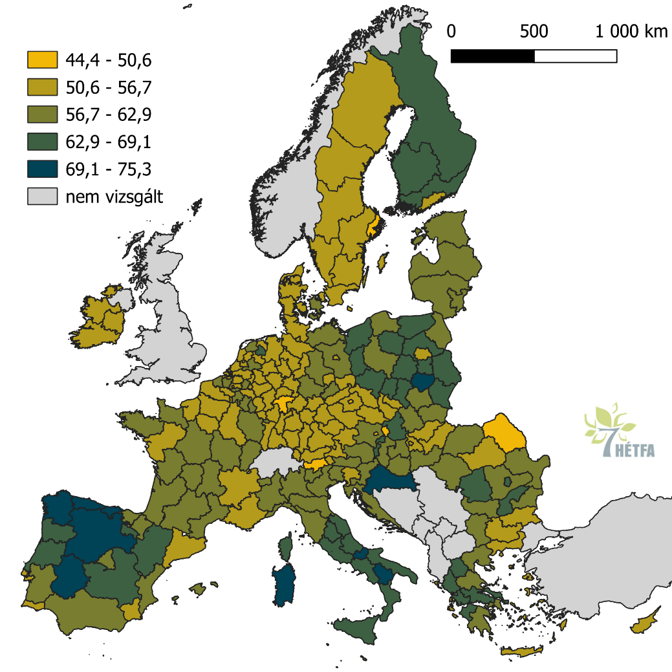
not examined

Source: Eurostat (proj_19rp3)

An ageing population has been identified as a contributing factor to the challenges of fiscal sustainability. The greater demands placed on health and long-term care by an ageing population necessitate additional infrastructure investments and adaptations to ensure accessibility for all. This, in turn, complicates the maintenance of adequate pensions, a problem that is especially pronounced for women, who often require more long-term care due to their longer life expectancy (Figure 2). In 2021, women’s pensions were, on average, 26.9% lower than those of men. According to the baseline scenario underlying the 2021 Ageing Report, the total cost of ageing, which amounted to 24% of GDP in 2019, is projected to increase by 1.9 percentage points of GDP by 2070.
The process of ageing in society engenders a number of issues that must be addressed, including but not limited to: the prevalence of loneliness amongst the elderly, energy poverty, the necessity for augmented capacity, and the affordability of care and healthcare. An ageing population invariably imposes greater demands on health and long-term care services, thereby precipitating escalating costs and exacerbating the shortage of professionals. Elderly individuals are predisposed to a higher incidence of chronic diseases such as dementia, cardiovascular diseases, cancer, and diabetes, which necessitate appropriate prevention, diagnosis, treatment, and care. Furthermore, the ageing demographic of healthcare professionals necessitates the consideration of issues such as burnout, stress, attrition, and retirement, which have the potential to impact the quality and safety of healthcare services. In this regard, there is a compelling need to implement strategies that focus on the retention, attraction, training, and motivation of the healthcare workforce. Such measures are essential for ensuring the effective functioning of healthcare systems and the delivery of high-quality care to individuals and communities.

Figure 2 Healthy life expectancy at age 65 in the European Union and Hungary in 2021 (years)
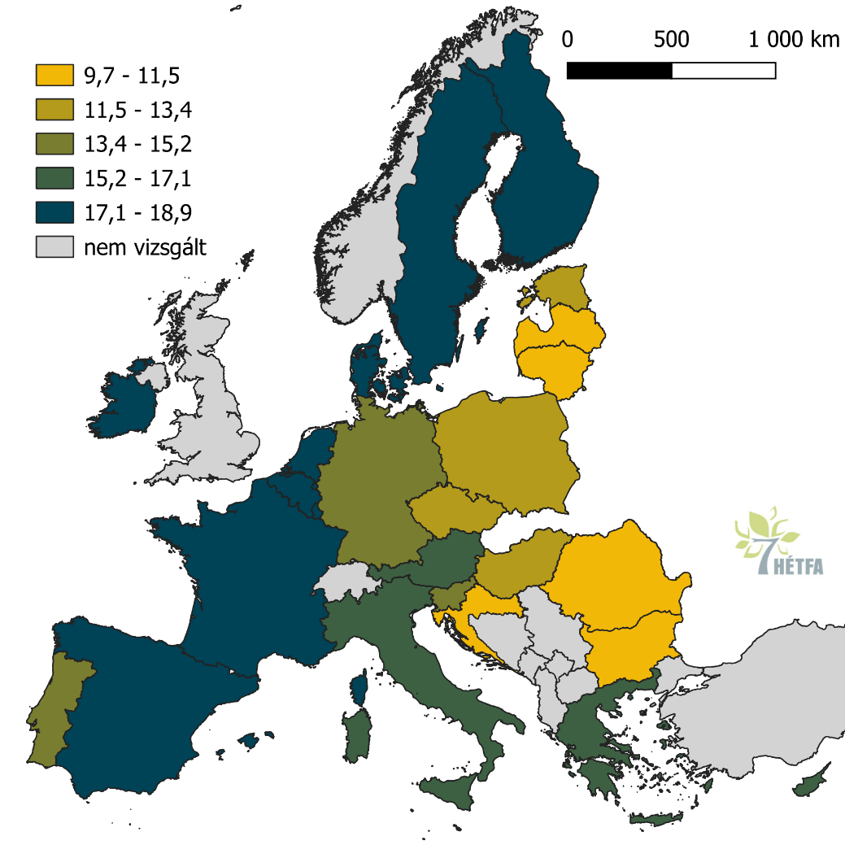
not examined

Source: Eurostat (hlth_silc_17)

It is imperative that care systems are adequately prepared to address the escalating demands. According to estimates by the Foundation for European Progressive Studies, the current number of individuals in Europe requiring long-term care stands at 24 million, with projections indicating a rise to 33 million by the year 2050. This demographic comprises individuals who receive institutional care (4 million), those receiving care in the comfort of their own homes (6 million), and a significant proportion of 14 million individuals who are not receiving any assistance. Furthermore, 20 million people require intermediate care, which is projected to rise to 29 million by 2050. Of these, 1.5 million receive care in the comfort of their own homes.
Early childhood care is another area where the need for care is growing, as the EU has set a target to increase the proportion of children in such services. Around 15.5 million children were enrolled in early childhood education in Europe in 2022. There are significant differences between Member States, reflecting the demographic structure of their populations and differences in the age of compulsory schooling. Differences also reflect national policies on early childhood education and care (ECEC) systems. From the age of three until the start of compulsory primary education, children in ECEC typically attend pre-primary programmes (ISCED level 0, category 020). In 2022, the share of children enrolled in early childhood education between the age of three and the start of compulsory primary education was 93.1% in the EU - see Figure 2. This is commonly referred to as the 3+ enrolment rate. In some countries, the rate is at or above the policy target of 96%: Sweden (96.1%), Portugal (96.3%), Lithuania and Spain (both 96.7%), Denmark (97.1%), Belgium (98.3%) and France (100.0%). It was between 90.0% and 95.9% in 11 countries, including Hungary and Italy, and between 80.0% and 89.9% in six EU countries. In Romania and Slovakia, it was below 80.0%.
Children in early childhood education from birth to the age of three are usually enrolled in early childhood development programmes (ISCED level 0, category 010). Norway (78.7%), Sweden (75.8%) and Denmark (75.5%) had the highest rates of children in early childhood education from birth to the start of compulsory primary education – the highest rates among EU countries. But it was also above 70% in Slovenia, Latvia, Spain and Lithuania. The countries with the lowest coverage were Slovakia (42.2%), Romania (42.9%) and the Czech Republic (45.1%). While Hungary and Italy are in the middle (see Figure 3).

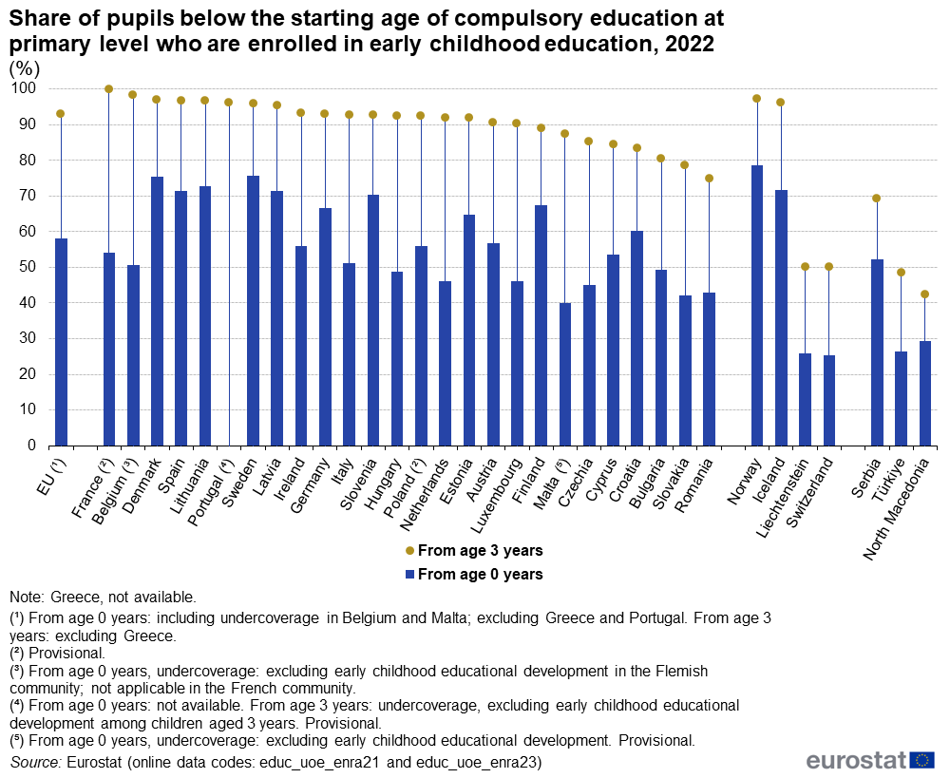
Figure 3 Share of pupils below the starting age of compulsory education at primary level who are enrolled in early childhood education
Source: Eurostat (educ_uoe_enra21) and (educ_uoe_enra23)

Eurostat also has data on teachers and educators in early childhood education, with more than 1.5 million Europeans working in this field in 2022. The largest number was in Germany (around half a million), followed by Spain (158,000) and Italy (128,000), with Hungary (26,000) and Romania (37,000) in the middle. 95% of teachers and childcare workers were women. The variation in absolute numbers is partly due to differences in the size and demographic structure of the countries, but also to differences in the ratio of carers/teachers per child. The average number of children per teacher in early childhood education also varies between Member States, ranging from 2.7 in Ireland to 13.8 in Romania. Lithuania is in the middle range (5.8), while Italy (11.1) and Hungary (12.6) have values similar to Romania.
In the European Union, the proportion of children at risk of poverty and social exclusion is stable. In 2023, 24.8% of Europeans under 18 was at risk of poverty or social exclusion, compared with 20.6% of adults. The data show that the higher the educational level of the parents, the lower the proportion of children at risk of poverty or social exclusion: 61.8% of children whose parents had a low educational level were at risk, compared with 10.7% of children whose parents had a high educational level. At national level, the highest rates were found in Romania (39.0%), Spain (34.5%) and Bulgaria (33.9%). The lowest rates were recorded in Slovenia (10.7%), Finland (13.8%) and the Netherlands (14.3%). While in most countries the rates are stable at the national level, Hungary recorded the largest increase in 2023, with a rise of 6.3 percentage points (pp), followed by Spain (+2.3 pp) and Luxembourg and Malta (+2.1 pp).
Furthermore, the necessity for care is projected to increase in conjunction with the ageing of the EU population. The proportion of individuals requiring care compared to those capable of providing it is projected to reach 76% by 2050. This anticipated demographic shift necessitates strategic action at the EU level. The data indicates that, while currently approximately 52 million Europeans, constituting 14.4% of the population aged 18 to 74, predominantly female, provide informal long-term care to family members or friends on a weekly basis. However, this care resource is set to become increasingly scarce numerically in the face of increasing demand, and this scarcity may be further heightened by intra- and cross-country mobility, which involves mostly the younger and middle generations.
The Labour Force Survey indicates that 16% of women not in the labour force who expressed an interest in employment cited caring responsibilities as their primary reason for being inactive. This figure is significantly higher than the 2% of men who reported the same reason. Furthermore, among those in part-time employment, 26% of women cited family care as their main reason for working part-time, compared with only 6% of men.

European Policy framework on ageing and care
The European Commission’s Green Paper on Ageing aims to discuss the social and economic impacts of ageing and possible responses. The Green Paper adopts a life-cycle approach, reflecting the universal impact of ageing on all generations and life stages. It covers the following topics:
- Healthy and active ageing, lifelong learning and regional differences in access to education.
- Increasing labour force participation, promoting productivity, innovation and business opportunities, and territorial aspects of employment and productivity.
- Active ageing, poverty in old age and adequate, equitable and sustainable pension systems.
- Meeting the health and long-term care needs of an ageing population, improving mobility, connectivity and accessibility, reducing territorial disparities in access to care and services, and improving well-being through intergenerational solidarity.
The European Care Strategy, which was presented by the Commission in September 2022, is centred on the needs of both carers and care recipients, with the overarching objective being to ensure the provision of quality, affordable and accessible care services throughout the EU. The strategy is divided into three key areas:
- Early Childhood Education and Care: the Commission will review the Barcelona targets and propose that Member States ensure that 45% of children under three, 95% of children between three and six, and 100% of children between six and the start of compulsory schooling receive quality childcare.
- Long-term care: The Commission proposes that Member States establish high-quality criteria and standards for care environments, enhance working conditions and work-life balance for carers, address training requirements and staff shortages for care staff, and promote legal migration pathways for care workers.
- Well-being of carers and cared-for persons: The Commission will support Member States in improving the health, mobility, connectivity and accessibility of carers and cared-for people, and in promoting intergenerational solidarity and social inclusion.
This strategy is in line with the implementation of the European Pillar of Social Rights and contributes to the recovery from the health crisis caused by the coronavirus.
Furthermore, the European Commission’s Recommendation 2008/876/EC on promoting the active inclusion of people excluded from the labour market requires Member States to provide services which are essential for active social and economic inclusion policies, including social assistance services, employment and training services, housing support and social housing programmes, childcare, long-term care support services and health services.
The Pan-European Individual Pension Product (PEPP) has been introduced as a voluntary personal pension scheme, with the purpose of allowing EU citizens to save for retirement in different Member States. The PEPP contains uniform product features and consumer protection rules, and is designed to complement existing public and occupational pension schemes. It is envisaged that PEPPs will be offered by a wide range of financial institutions, and savers will be free to choose between different investment options. A notable feature of PEPPs is their portability, which enables savers to open a sub-account with the same provider in another Member State in the event of relocation. The PEPP Regulation (2019/1238) came into effect on 28 March 2022, with the EU aiming to increase the share of private pension savings to at least 33% by 2030.
The Council Recommendation on access to affordable and high-quality long-term care (2022/C 476/01) provides guidance to Member States to strengthen the adequacy, accessibility and quality of long-term care and to improve the working conditions of carers, for all those who need it. Early childhood education and care is also an important strategic area for the European Union, which includes private and community early childhood services.
A Council Recommendation on a high-quality early childhood education and care system was adopted in May 2019. The Council Recommendation aims to improve access to and the quality of early childhood education and care. It sets out a quality framework which identifies five key components: access to early childhood education and care; training and working conditions of early childhood education and care staff; definition of appropriate curricula; governance and funding; and monitoring and evaluation of systems. A quality framework has helped to improve the provision of early childhood education and care. For example, several countries have already reached the EU-wide target of 95% of children over four years of age participating in ECEC.
In 2021, the European Children’s Guarantee was adopted. The overarching aim of the European Children’s Guarantee is to prevent and combat social exclusion by ensuring effective access to a range of key services for children in need. The following services are to be made available free of charge:
- Early childhood education and care,
- Free education (including school activities and at least one healthy meal every school day),
- Free health care,
- Healthy nutrition, and
- Adequate housing.
While the majority of children in the EU already have access to these services, inclusive and truly universal access is vital, especially for those who experience social exclusion due to poverty or other disadvantages. In order to implement the aforementioned Recommendation, Member States have appointed Child Guarantee Coordinators and prepared National Action Plans covering the period up to 2030. Member States encountering levels of child poverty that exceed the EU average (23.4% - AROPE 2017-2019) are obligated to allocate a minimum of 5% of their European Social Fund (ESF+) resources to the mitigation of child poverty.

Social care sector in Europe
The estimation of the number of professionals working in the care sector is challenging due to the ambiguity of the sector’s boundaries and the prevalence of undeclared employment. Based on these considerations, it is estimated that approximately 12 million care workers are present in the EU. Of these, 3.1 million are migrants, of whom 2.8 million are female, thus emphasising the importance of considering intersectional inequalities and vulnerabilities.
It is evident that care workers are more likely to be in the bottom third of the wage distribution, more likely to have temporary contracts, and more likely to be undeclared. This suggests that they are deprived of legal guarantees and social protection. The data from the European Labour Authority indicates that 36% of care workers work in undeclared conditions, while this share in the private sector is considered to be 8%. The probability of under-declaration of employment is also elevated; however, the availability of data on this phenomenon remains limited. The aforementioned conditions have a disproportionately negative impact on women, as evidenced by the fact that 90% of care workers are female. This phenomenon perpetuates an intractable cycle of disadvantage.
The prevailing challenges within health systems, including but not limited to elevated levels of stress, burnout, absenteeism and industrial action among the health and care workforce, are indicative of a state of affairs that is suboptimal. Such symptoms are manifestations of adverse conditions, including but not limited to staff shortages, low remuneration, suboptimal and hazardous working environments, and an absence of requisite workplace safeguards. A survey conducted between January 2020 and April 2022 revealed that at least 25% of health and care workers reported symptoms consistent with anxiety, depression and burnout. No significant reductions in these symptoms have been observed since 2022.

The Pact for Skills: a large-scale skills partnership for ageing care
The establishment of a comprehensive skills development partnership for the elderly care sector has been achieved by care providers, social partners and education and training institutions, with the support of the European Commission. The aim of the partnership is twofold: firstly, to improve career opportunities in the sector and raise the quality of care, and secondly, to make the sector more attractive. The partners have committed to providing training to a minimum of 60% of all professionals working in the care sector by 2030, which equates to 3.8 million workers. The training will be centred on digital skills and personalised care. Europe’s ageing society is creating a growing need for carers. The current workforce in the care sector in the EU is estimated to be 6.3 million, and it is projected that by 2050, the demand for care will increase by 1.6 million to maintain current levels of care. In order to address the shortage of labour, it is essential that the sector enhances its capacity to attract and retain professionals. This can be achieved through upgrading skills and creating more opportunities for further training. This initiative will also promote gender equality, as women constitute nearly 90% of the care workforce.
Ultimately, the partnership will promote the exchange of experiences and effective practices with pertinent authorities, educational and health institutions, and other social care actors.

References
Council of the European Union (2019). Council Recommendation of 8 December 2022 on access to affordable high-quality long-term care (2022/C 476/01). https://eur-lex.europa.eu/legal-content/EN/TXT/PDF/?uri=CELEX:32022H1215(01)
Council of the European Union (2019). Council Recommendation of 22 May 2019 on High-Quality Early Childhood Education and Care Systems (2019/C 189/02).
Council of the European Union (2021). Council Recommendation (EU) 2021/1004 of 14 June 2021 establishing a European Child Guarantee ST/9106/2021/INIT.
Commission of the European Communities (2008). Communication from the Commission to the European Parliament, the Council, the European Economic and Social Committee and the Committee of the Regions – Cohesion Policy: investing in the real economy /* COM/2008/0876 final */. https://eur-lex.europa.eu/legal-content/EN/TXT/HTML/?uri=CELEX:52008DC0876&from=MT
European Commission (2017). An evaluation of the scale of undeclared work in the European Union and its structural determinants. Publications Office of the European Union. https://www.ela.europa.eu/sites/default/files/2021-09/KE-06-17-268-EN-N.pdf
European Commission (2021). The 2021 Ageing Report. Economic & Budgetary Projections for the EU Member States (2019-2070) (European Economy – Institutional Paper No. 148). https://economy-finance.ec.europa.eu/publications/2021-ageing-report-economic-and-budgetary-projections-eu-member-states-2019-2070_en
European Commission (2022). A European Care Strategy for caregivers and care receivers. https://employment-social-affairs.ec.europa.eu/news/european-care-strategy-caregivers-and-care-receivers-2022-09-07_en#navItem-relatedDocuments
European Commission (2022). Green paper on ageing. Publications Office of the European Union. https://data.europa.eu/doi/10.2775/785789
European Commission (2022). Pan-European private pension product (PEPP). https://ec.europa.eu/commission/presscorner/detail/en/ip_22_1941
European Commission (2023). Flash Eurobarometer 534: Demographic change in Europe. Directorate-General for Communication, Secretariat-General. https://data.europa.eu/data/datasets/s3112_fl534_eng?locale=en
European Commission (2023). Pact for Skills: launch of a large-scale skills partnership for long-term care. https://employment-social-affairs.ec.europa.eu/news/pact-skills-launch-large-scale-skills-partnership-long-term-care-2023-04-20_en
European Commission (2023). 2023 State of the Union Address by President von der Leyen. https://ec.europa.eu/commission/presscorner/detail/en/speech_23_4426
European Institute for Gender Equality (2021). Gender inequalities in care and consequences for the labour market. https://eige.europa.eu/publications-resources/publications/gender-inequalities-care-and-consequences-labour-market
European Labour Authority (2022). Tackling undeclared work in the personal and household services sector. https://www.ela.europa.eu/sites/default/files/2022-03/UDW_Study_report_on_PHS_2022.pdf
Eurostat (2023). Population projections – baseline scenario (proj_19rp3). European Commission. https://ec.europa.eu/eurostat/databrowser/view/proj_19rp3/default/table?lang=EN
International Labour Organization (ILO) (2018). Care work and care jobs for the future of decent work. https://www.ilo.org/global/publications/books/WCMS_633135/lang--en/index.htm
Kiss, M. (2022). Demographic outlook for the European Union. European Parliamentary Research Service. https://www.europarl.europa.eu/RegData/etudes/STUD/2022/729461/EPRS_STU(2022)729461_EN.pdf.
Thissen, L., & Mach, A. (Eds.). (2023). The European care strategy: A chance to ensure inclusive care for all? Foundation for European Progressive Studies & Friedrich-Ebert-Stiftung. Authors: C., Navarra, M., Fernandes, C., Saraceno, A., Gromada, T., Bell, C., Marzo, J. F., Lebrun, B., Helfferich, E., Chieregato, & F., Sanden.
Válasz Online (2025, April 2). Valami nagyon nem stimmel a KSH szegénységi adataival (Something is very wrong with the Hungarian Central Statistical Office’s poverty data). https://www.valaszonline.hu/2025/04/02/ksh-eurostat-szegenyseg-inflacio-jovedelmek-megbizhatosag/
World Health Organization (2015). World report on ageing and health. https://www.who.int/publications/i/item/9789241565042
World Health Organization (2024). Protecting health and care workers’ mental and well-being: Technical Consultation Meeting. https://www.who.int/news/item/25-04-2024-202404_protecthw_mentalhealth




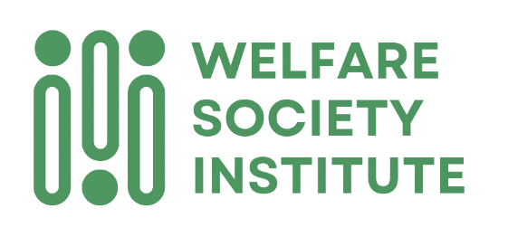


Funded by the European Union. Views and opinions expressed are however those of the author(s) only and do not necessarily reflect those of the European Union or the European Education and Culture Executive Agency (EACEA). Neither the European Union nor EACEA can be held responsible for them.

This project has received funding from the European Union’s Horizon Europe programme under Agreement No 2024-1-RO01-KA220-ADU-000251559 PU – Public (fully open, automatically posted online on the Project Result platforms); SE – Sensitive (limited under the conditions of the Grant Agreement); CO – EU classified: EU restricted, EU confidential, EU secret under Decision 2015/444
European Commission (2023). 2023 State of the Union Address by President von der Leyen. https://ec.europa.eu/commission/presscorner/detail/en/speech_23_4426
European Commission (2023). Flash Eurobarometer 534: Demographic change in Europe. Directorate-General for Communication, Secretariat-General. https://data.europa.eu/data/datasets/s3112_fl534_eng?locale=en
Eurostat (2023). Population projections – baseline scenario (proj_19rp3). European Commission. https://ec.europa.eu/eurostat/databrowser/view/proj_19rp3/default/table?lang=EN
European Commission (2021). The 2021 Ageing Report. Economic & Budgetary Projections for the EU Member States (2019-2070) (European Economy – Institutional Paper No. 148). https://economy-finance.ec.europa.eu/publications/2021-ageing-report-economic-and-budgetary-projections-eu-member-states-2019-2070_en
World Health Organization (2015). World report on ageing and health. https://www.who.int/publications/i/item/9789241565042
Thissen, L., & Mach, A. (Eds.). (2023). The European care strategy: A chance to ensure inclusive care for all? Foundation for European Progressive Studies & Friedrich-Ebert-Stiftung. Authors: C., Navarra, M., Fernandes, C., Saraceno, A., Gromada, T., Bell, C., Marzo, J. F., Lebrun, B., Helfferich, E., Chieregato, & F., Sanden.
Although the reliability of the poverty data provided by the Hungarian Central Statistical Office has been questioned by several experts, for example, in Válasz Online (2025, April 2). Valami nagyon nem stimmel a KSH szegénységi adataival (Something is very wrong with the Hungarian Central Statistical Office’s poverty data). . https://www.valaszonline.hu/2025/04/02/ksh-eurostat-szegenyseg-inflacio-jovedelmek-megbizhatosag/
Kiss, M. (2022). Demographic outlook for the European Union. European Parliamentary Research Service. https://www.europarl.europa.eu/RegData/etudes/STUD/2022/729461/EPRS_STU(2022)729461_EN.pdf. The share who could provide care is approximated by the number of working-age people (aged 15-64 years) who could directly provide care or help to finance it.
European Commission (2021). The 2021 Ageing Report. Economic & Budgetary Projections for the EU Member States (2019-2070) (European Economy – Institutional Paper No. 148). https://economy-finance.ec.europa.eu/publications/2021-ageing-report-economic-and-budgetary-projections-eu-member-states-2019-2070_en
Thissen, L., & Mach, A. (Eds.). (2023). The European care strategy: A chance to ensure inclusive care for all? Foundation for European Progressive Studies & Friedrich-Ebert-Stiftung. Authors: C., Navarra, M., Fernandes, C., Saraceno, A., Gromada, T., Bell, C., Marzo, J. F., Lebrun, B., Helfferich, E., Chieregato, & F., Sanden.
European Commission (2022). Green paper on ageing. Publications Office of the European Union. https://data.europa.eu/doi/10.2775/785789
European Commission (2022). A European Care Strategy for caregivers and care receivers. https://employment-social-affairs.ec.europa.eu/news/european-care-strategy-caregivers-and-care-receivers-2022-09-07_en#navItem-relatedDocuments
Commission of the European Communities (2008). Communication from the Commission to the European Parliament, the Council, the European Economic and Social Committee and the Committee of the Regions – Cohesion Policy: investing in the real economy /* COM/2008/0876 final */. https://eur-lex.europa.eu/legal-content/EN/TXT/HTML/?uri=CELEX:52008DC0876&from=MT
European Commission (2022). Pan-European private pension product (PEPP). https://ec.europa.eu/commission/presscorner/detail/en/ip_22_1941
Council of the European Union (2019). Council Recommendation of 8 December 2022 on access to affordable high-quality long-term care (2022/C 476/01). https://eur-lex.europa.eu/legal-content/EN/TXT/PDF/?uri=CELEX:32022H1215(01)
Council of the European Union (2019). Council Recommendation of 22 May 2019 on High-Quality Early Childhood Education and Care Systems (2019/C 189/02).
Council of the European Union (2021). Council Recommendation (EU) 2021/1004 of 14 June 2021 establishing a European Child Guarantee ST/9106/2021/INIT.
European Institute for Gender Equality (EIGE) (2021), ibid, International Labour Organization (ILO) (2018). Care work and care jobs for the future of decent work. https://www.ilo.org/global/publications/books/WCMS_633135/lang--en/index.htm
Thissen, L., & Mach, A. (Eds.). (2023). The European care strategy: A chance to ensure inclusive care for all? Foundation for European Progressive Studies & Friedrich-Ebert-Stiftung. Authors: C., Navarra, M., Fernandes, C., Saraceno, A., Gromada, T., Bell, C., Marzo, J. F., Lebrun, B., Helfferich, E., Chieregato, & F., Sanden.
European Labour Authority (2022). Tackling undeclared work in the personal and household services sector. https://www.ela.europa.eu/sites/default/files/2022-03/UDW_Study_report_on_PHS_2022.pdf; European Commission (2017). An evaluation of the scale of undeclared work in the European Union and its structural determinants. Publications Office of the European Union. https://www.ela.europa.eu/sites/default/files/2021-09/KE-06-17-268-EN-N.pdf
European Institute for Gender Equality (2021). Gender inequalities in care and consequences for the labour market. https://eige.europa.eu/publications-resources/publications/gender-inequalities-care-and-consequences-labour-market
World Health Organization (2024). Protecting health and care workers’ mental and well-being: Technical Consultation Meeting. https://www.who.int/news/item/25-04-2024-202404_protecthw_mentalhealth
European Commission (2023). Pact for Skills: launch of a large-scale skills partnership for long-term care. https://employment-social-affairs.ec.europa.eu/news/pact-skills-launch-large-scale-skills-partnership-long-term-care-2023-04-20_en

